1. Write a program to create an item collection and clones the items using AngularJS directives.

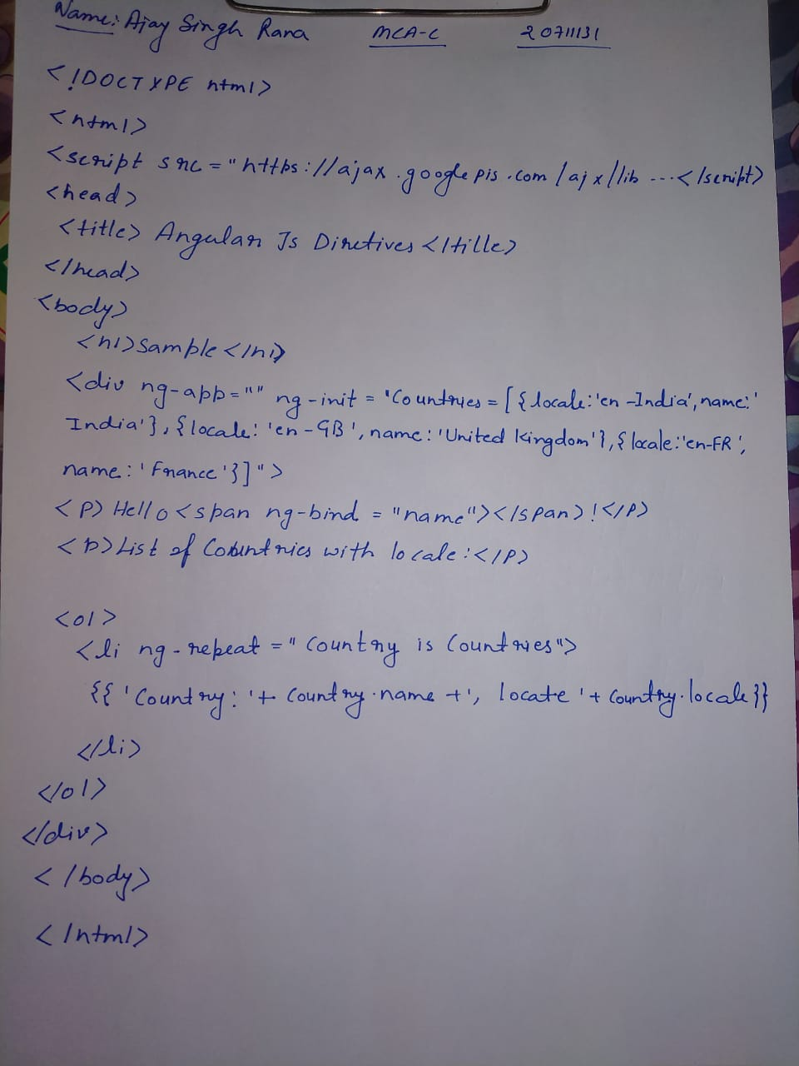

OUTPUT

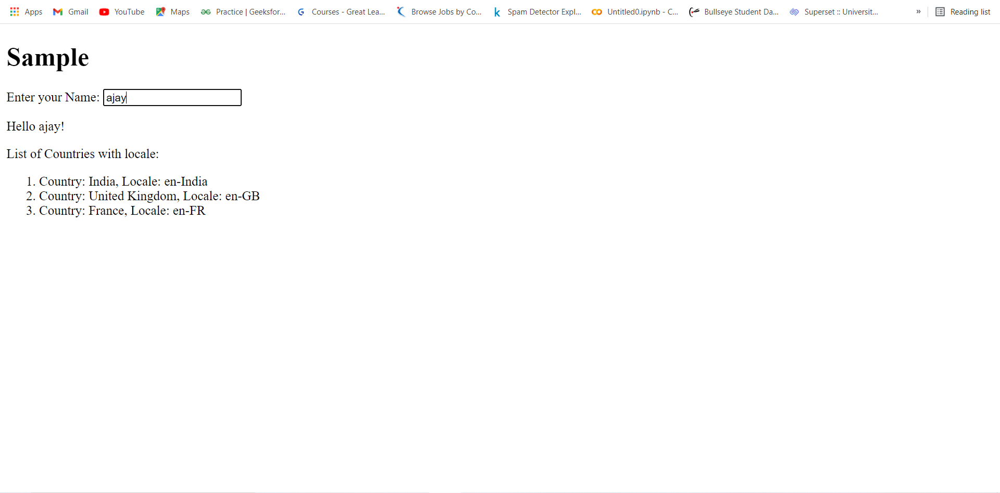

2. Write a program to create an HTTP server which can communicate between client and the server.

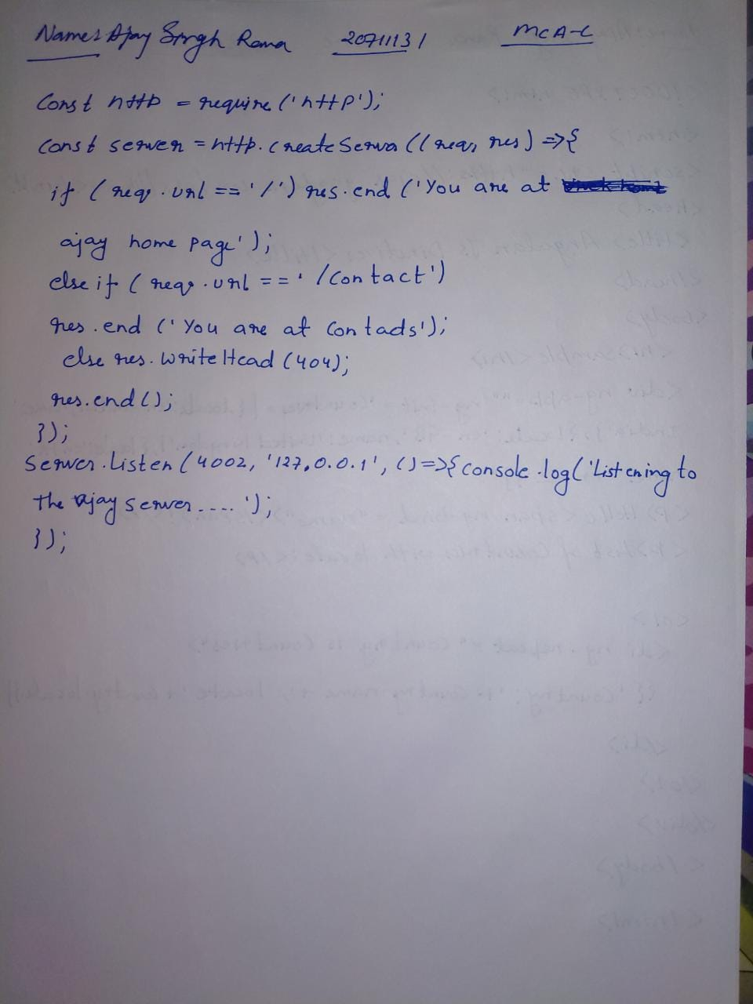

Output

